HRS orange shoes return to the NEC for World Biogas Expo 2025
HRS Heat Exchangers, Stand B20, World Biogas Expo, NEC Birmingham, 9-10 July 2025

The experienced team from HRS Heat Exchangers will return to the NEC in July, where visitors will quickly be able to identify them thanks to trademark orange shoes. They will be happy to discuss the importance of biogas project optimisation in an increasingly uncertain world and provide real case studies using HRS systems and components from biogas projects around the globe.
Over the course of its 40-year history, HRS Heat Exchangers has become a global leader in heat exchange technology for the AD and biogas sector, with systems for digester heating, pasteurisation, digestate concentration, biogas dehumidification, and sludge and exhaust gas heat recovery. HRS equipment is installed at more than 200 biogas plants worldwide, helping operators to improve their efficiency and overall operation.
Despite a number of challenges and uncertainties for the global biogas sector, this highly versatile technology which provides numerous benefits continues to deliver good news stories, such as the recent biogas plant in South Dakota which is delivering almost 780 m³/hr of biomethane. Last year HRS delivered its largest ever order for 384 heat exchanger modules (weighing a total of 126 tonnes) to a client in North America for a renewable energy project.
Closer to home, the National Farmers Union (NFU) continues to push for more on-farm use of anaerobic digestion and deliver on its ambition for 1,000 on-farm biogas plants in the UK, around double the current number¹.
“Global economic challenges mean that financing new plants can be difficult, even where governments are supportive,” comments Matt Hale, HRS Heat Exchanger’s Global Key Account Director. “One way to improve economic returns and maximize biogas production is to upgrade existing plants, and in particular maximize efficiency at every stage of the process.

“HRS produce a range of heat exchangers and complete systems for the biogas sector which recapture energy which would otherwise go to waste, utilizing it for activities including digester heating, digestate treatment, biogas dehumidification or exhaust gas heat recovery – often with much greater efficiency than alternative techniques.”

HRS Heat Exchangers’ wide range of products and systems for AD and biogas include:
- HRS DTI Series for digester heating
- HRS G Series for exhaust gas heat recovery
- HRS Biogas Dehumidification System (BDS), which removes water from biogas, protecting CHP engines from corrosion and cavitation
- HRS Digestate Pasteurization System (DPS) to produce PAS110 compliant digestate
- HRS Digestate Concentration System (DCS) which uses patented technology to significantly reduce the volume of digestate using much less energy than a dryer or batch evaporation

A number of these systems have been installed across the UK and Europe, as well as being utilised in anaerobic digestion projects as far afield as North America, Spain, Eastern Europe, and Australia and New Zealand.
To learn more about HRS Heat Exchangers’ wide range of heat transfer solutions and dedicated systems to boost efficiency and add value to AD and biogas installations, visit Stand B20 at the World Biogas Expo, NEC, Birmingham on 9-10 July 2024.
End.
NOTES TO EDITORS - Images attached with captions
¹ https://www.nfuonline.com/updates-and-information/anaerobic-digesters-underutilised-in-the-uk/

The HRS team and their trademark orange shoes will return to the World Biogas Expo in Birmingham in 2025  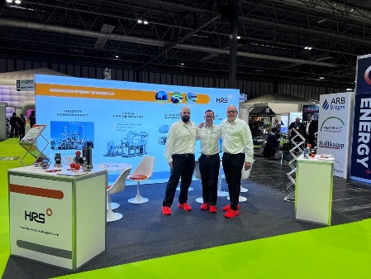 | External digester heating using the HRS DTI Series of heat exchangers provides a number of benefits  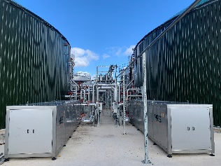 | The HRS Digestate Concentration System (DCS) reduces digestate volume and reduces ammonia emissions  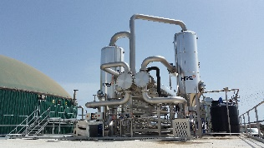

HRS K Series heat exchangers have been supplied to dehumidify biogas for Australia’s largest landfill biogas company  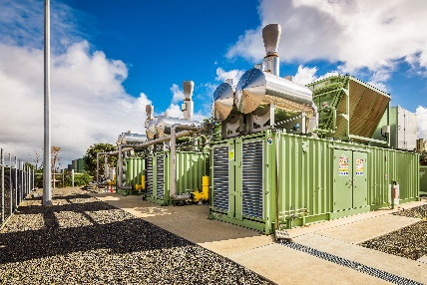 | An HRS Digestate Pasteurisation System (DPS) installed at a Lithuanian AD plant  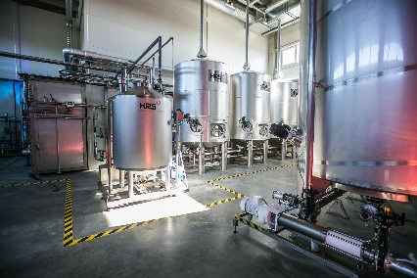 | An HRS Digestate Pasteurisation System (DPS) installed at New Zealand’s first dedicated food waste AD plant  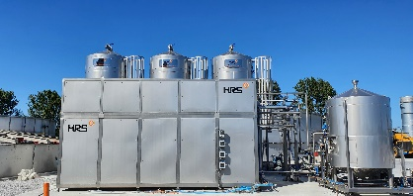

About HRS Heat Exchangers
Located in the UK, HRS Heat Exchangers is part of the EIL Group (Exchanger Industries Limited) which operates at the forefront of thermal technology. HRS offers innovative heat transfer solutions worldwide across a diverse range of industries. With more than 40 years’ experience in the anaerobic digestion and biogas sector, specialising in the design and manufacture of an extensive range of turnkey systems and components, incorporating our corrugated tubular and scraped surface heat exchanger technology, HRS products are compliant with global design and industry standards. HRS has a network of offices throughout the world: Australia, Canada, New Zealand, UK, Spain, USA, Malaysia and India; with manufacturing plants in India, Spain and Canada.

For UK media enquiries about HRS Heat Exchangers please contact:
Yenni Maelianawati, Senior Marketing Manager, 3 Abloy House, Hatters Lane, Watford, Hertfordshire, WD18 8AJ
Tel: +44 (0) 1923 545 625
Direct Email: yenni@uk.hrs-he.com
Email for publication: info@uk.hrs-he.com
www.hrs-heatexchangers.com

Release issued for HRS Heat Exchangers by FastLoop Media:
Bev Small, FastLoop Media
T +44 (0) 7901 841491 E bev@fastloopmedia.com

Kate O’Reilly, FastLoop Media
T +44 (0)7894 039 609 E kate@fastloopmedia.com
W www.fastloopmedia.com



